­

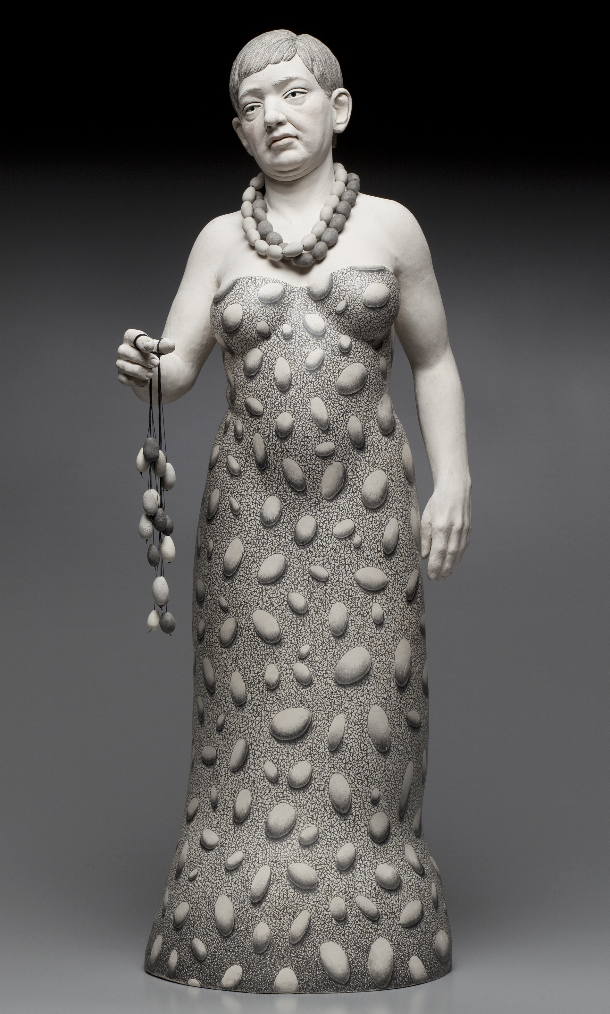

**Claudia Olds Goldie: *Staccato***

**April 3 – May 5, 2019**

**Reception & Artist Talks**

Saturday, April 13, 3–5pm, talks begin 4pm

**First Friday Receptions**

April 5 & May 3, 6-9pm

**Closing Reception & Concert**

Sunday, May 5, 4–6pm

**Gallery Hours**

Wednesday – Sunday, 11am–5pm

Boston Sculptors Gallery presents Claudia Olds Goldie: *Staccato*, anexciting collection of figurative and abstract sculptures texturally linked by their intricately patterned surfaces, on view April 3 through May 5, 2019. Intricate graphite pencil drawings on white ceramic clay masquerade as textile designs on some figures, and on others as extensive body tattoos, with the uncanny ability to mask nakedness and vulnerability. As an artist known for her figurative work, Olds Goldies’ recent embrace of the abstract allows to alter her voice in a manner that remains harmonious and related to the figure.

*Staccato* is named for the monumental ceramic wall sculpture that is its focal piece. A sprawling arrangement composed of 84 individual parts, *Staccato* is inspired by the visual form of musical articulation, which directs how notes or passages are played or sung. The varied and complex marks that Olds Goldie makes on the sculpture’s surface suggest the multiple ways the viewer may interpret the work.

Claudia Olds Goldie is a 2017 Mass Cultural Council finalist. She received a nomination for a Boston Foundation Brother Thomas Fellowship, a Kiln God residency from Watershed Center for Ceramics, and a fellowship from the Vermont Studio Center. Olds Goldie has had numerous solo exhibitions and shown nationally in such shows as the NCECA Biennial in Houston, SOFA Chicago, numerous State of Clay national exhibitions, Fuller Craft Museum, Ohio Craft Museum’s *Figure It* Invitational, and *Contemporary Figurative Sculpture* at Santa Fe Clay Gallery.

Claudia Olds Goldie: *Staccato* runs concurrently with Leslie Wilcox: *Enrootables*.

# # #

**Contacts:** Almitra Stanley, Director Claudia Olds Goldie

617.482.7781 617.680.9491

[bostonsculptors@gmail.com](mailto:bostonsculptors@gmail.com) [claudia.olds.goldie@gmail.com](mailto:claudia.olds.goldie@gmail.com)

[bostonsculptors.com](https://www.bostonsculptors.com/) [claudiaoldsgoldie.com](http://claudiaoldsgoldie.com/)